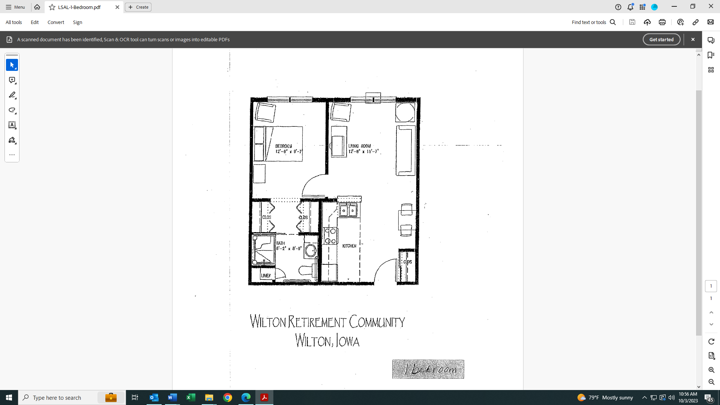

**Leland R. Smith Assisted Living**

**One Bedroom One Bathroom**