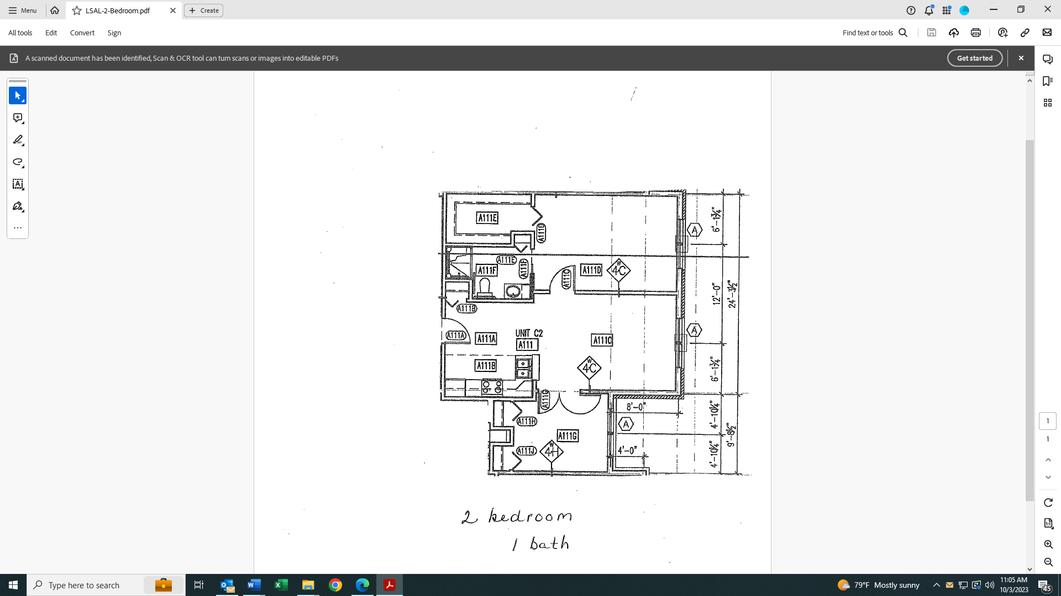

**Leland R. Smith Assisted Living**

**2 Bedroom 1 Bathroom**