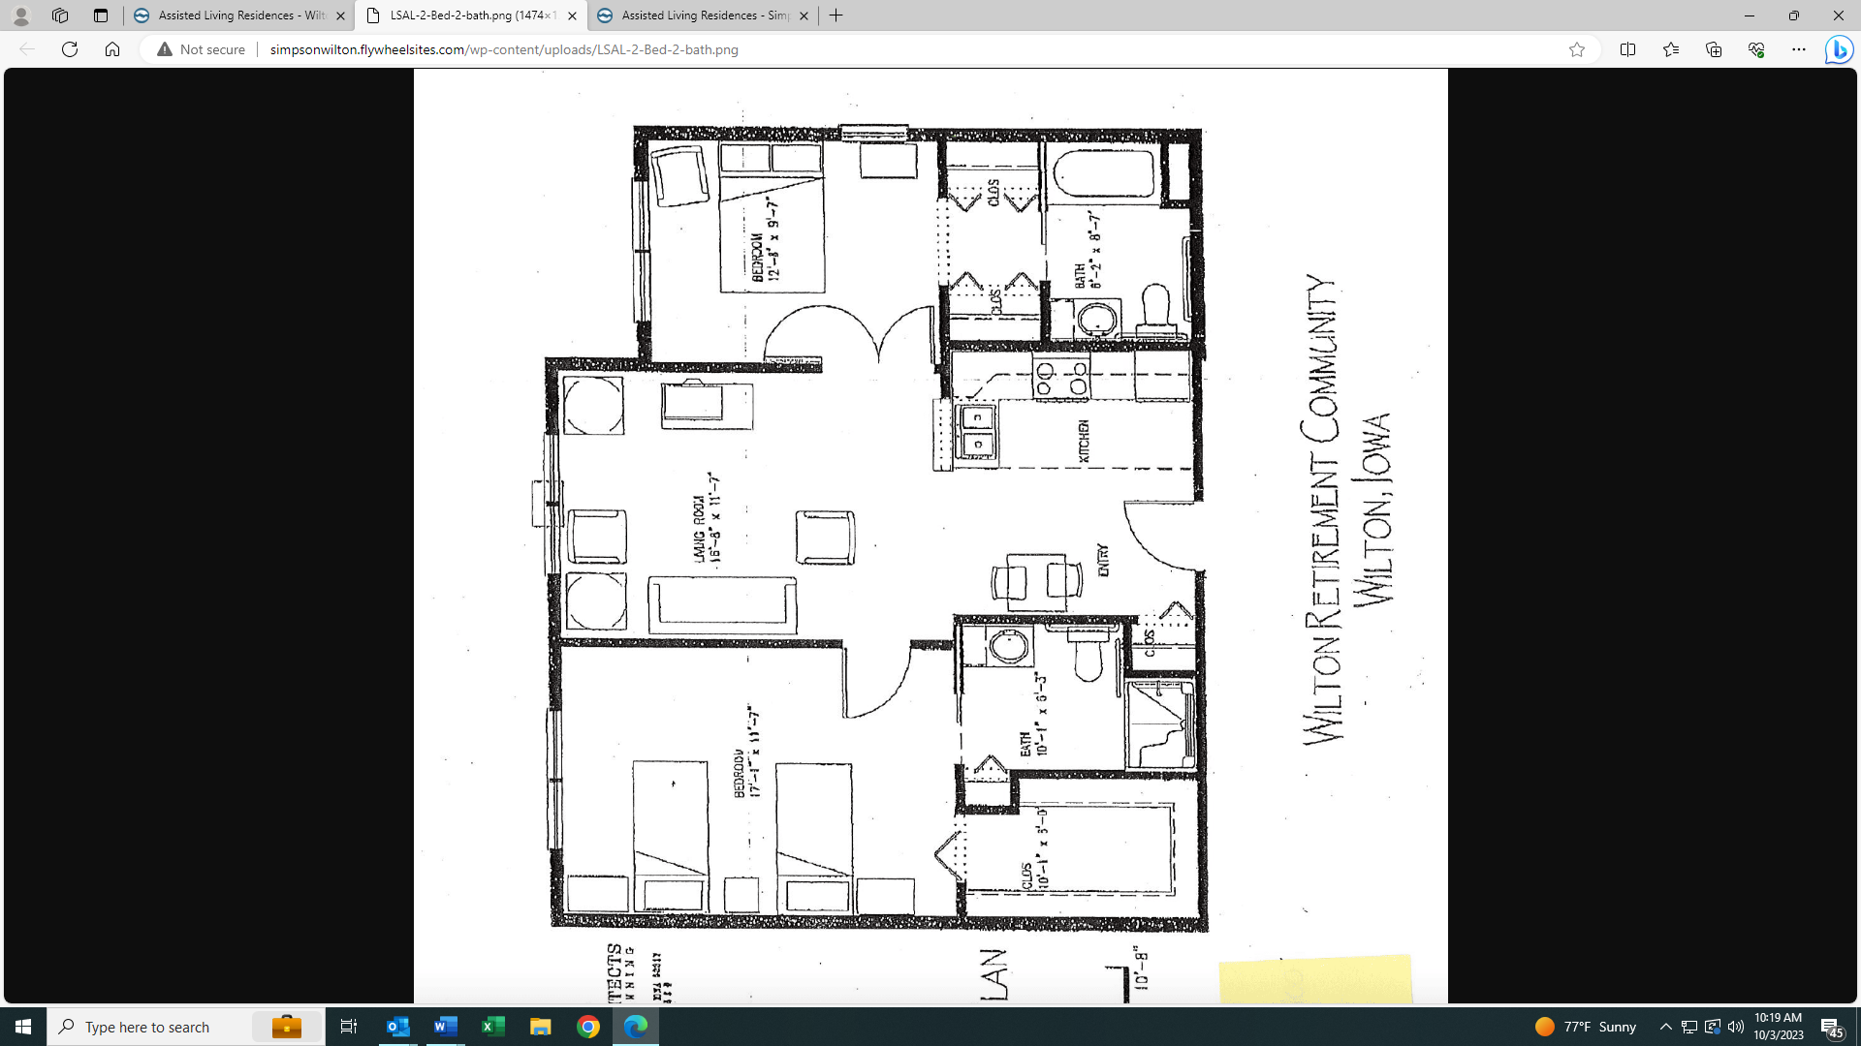

Leland R. Smith Assisted Living

Two Bedroom Two Bathroom Apartment