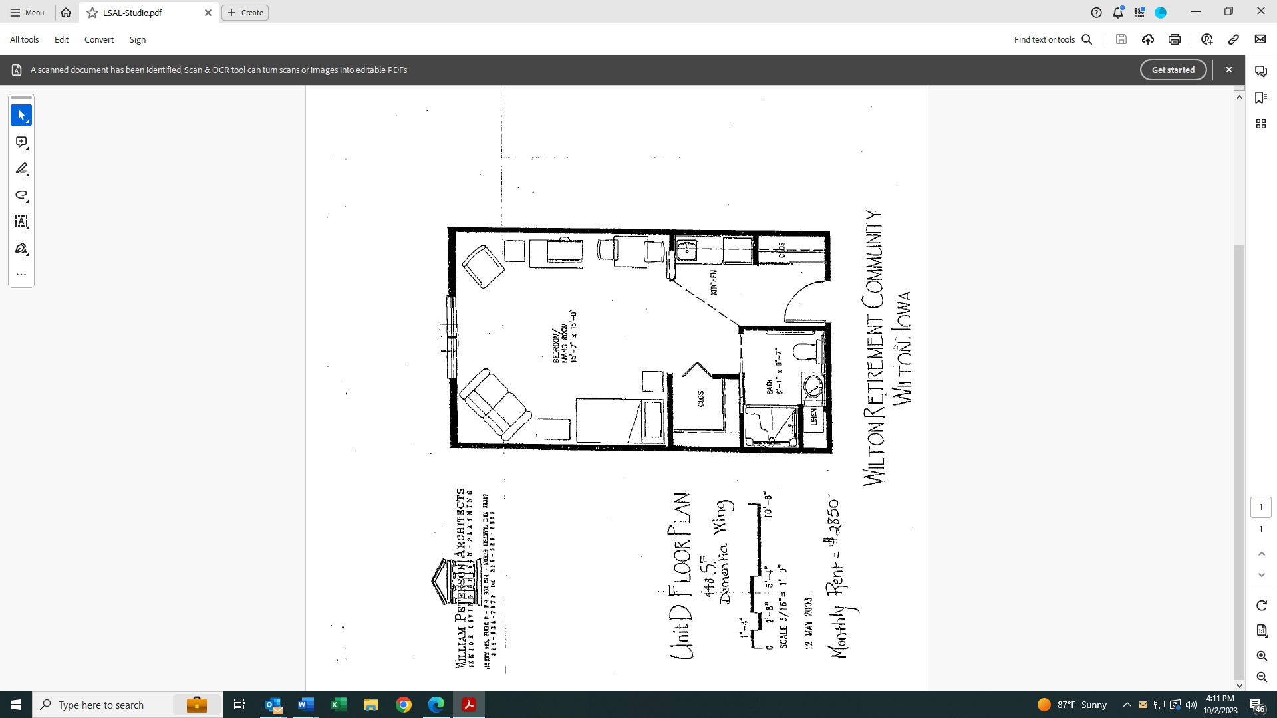

**Leland R. Smith Assisted Living**

**Studio Apartment**